## **Objective**

This distance learning program aims to educate students about the nature of political compromise by exploring the Compromise of 1850. Students will be introduced to several primary source documents ahead of the presentation. During the virtual presentation, the ranger will lead a facilitated dialogue with students to examine both the history of slavery and the nature of political compromise in the United States. By the end of the lesson, students will better understand how difficult it can be to compromise with deeply held personal values, and how compromise can sometimes lead to unintended consequences.

## **Pre-Visit Resources**

* Article: Khan Academy, “[The Compromise of 1850](https://www.khanacademy.org/humanities/us-history/civil-war-era/sectional-tension-1850s/a/compromise-of-1850)”
* Article: Ohio History Central, “[The Fugitive Slave Law of 1850](https://ohiohistorycentral.org/w/Fugitive_Slave_Law_of_1850)”
* Video: “[The Story of Anthony Burns and the Fugitive Slave Act of 1850](https://www.youtube.com/watch?v=x-Of33j4qFg)”
* Map: “[Compromise of 1850 Map](https://upload.wikimedia.org/wikipedia/commons/0/0b/The_making_of_the_American_nation%3B_a_history_for_elementary_schools_%281905%29_%2814595017308%29.jpg)”
* Cartoon: “[The Clay Compromise: A Settler](https://digital.librarycompany.org/islandora/object/Islandora%3A65074)”
* Cartoon: “[Congressional Scales: A True Balance](https://historymaking.org/textbook/files/original/773ff38a3fe08dfba7b869dff56824e1.jpg)”
* Cartoon: “[Effects of the Fugitive Slave Law](https://www.loc.gov/resource/cph.3a05114/)”
* Speech: Senator Daniel Webster, “Seventh of March” Speech
* Speech: Senator John Calhoun Speech Against the Compromise of 1850
* Speech: Frederick Douglass, “The Fugitive Slave Law”

1. All students will read two short articles on the Compromise of 1850, watch a five-minute video, and examine a map about the compromise. The remainder of the pre-visit resources can be divided among the students.
2. Each student will closely examine one political cartoon (click on hyperlinks within titles for larger images) and one speech. The teacher may elect to have the students work in groups or individually.
3. During the virtual meeting, the ranger will facilitate a conversation with students about the Compromise of 1850 using the materials that the students worked on ahead of time.

## **Vocabulary Sheet**

**Abolitionist:** A person who opposed slavery and called for its immediate abolition.

**Census:** An official count of a population. In the United States, the census count for the entire nation is done every ten years (1800, 1810, 1820, etc.).

**Fugitive Slave:** An enslaved person who tries to run away from their enslaver and becomes a “fugitive” of the law.

**Injunction:** A direct order or law.

**Jury:** A body of people who are sworn to hear evidence in a court case and offer a verdict. Oftentimes there are twelve members in a jury.

**Popular Sovereignty**: Settlers in a territory are given the option to determine whether or not they wanted slavery in their lands. “Sovereignty” is a group of people or government with the highest power. Therefore “popular sovereignty” is the idea that the people themselves—not the federal government—are the highest authority.

**Samaritan:** a person who goes out of their way to help or provide charity to someone else.

**Secession:** a term used for a group of people who try to leave a country to form their own separate country.

**Territory:** In U.S. law, an area of land that has applied for statehood and is working to write a state constitution and become a state.

**Union:** a term sometimes used interchangeably with “United States.” Often used to signify the union of all U.S. states.

## **Activity A: Articles on the Compromise of 1850 and The Fugitive Slave Act**

1. In at least two sentences, describe what the “Mexican Cession” was and how the United States acquired it.
2. Who was the political leader who called for compromise over the Mexican Cession, and what was his original proposal?
3. List two benefits for opponents of slavery and two benefits for supporters of slavery in the Compromise of 1850:

**Antislavery:**

**Proslavery:**

1. In at least three sentences, describe how the Fugitive Slave Act worked.
2. Why do you think some African Americans choose to run away to Canada instead of staying in a Northern U.S. state?

## **Activity B: “The Story of Anthony Burns and the Fugitive Slave Act of 1850”**

1. Anthony Burns was an African American man living in Boston when he was arrested in 1854. Why was he arrested?
2. Why did President Franklin Pierce insist on having Anthony Burns arrested? Who was he trying to please with this action?
3. Why did Frederick Douglass express little sympathy for the death of Deputy Marshall Batchelder? What was his point of view on the Anthony Burns case?
4. In the aftermath of the Burns case, what did proslavery Southerners have to say about the Fugitive Slave Act?
5. In your opinion, was Boston’s abolitionist community justified in their attempt to free Anthony Burns? Is violence ever justified?

## **Activity C:** [**Map of the Compromise of 1850**](https://upload.wikimedia.org/wikipedia/commons/0/0b/The_making_of_the_American_nation%3B_a_history_for_elementary_schools_%281905%29_%2814595017308%29.jpg)

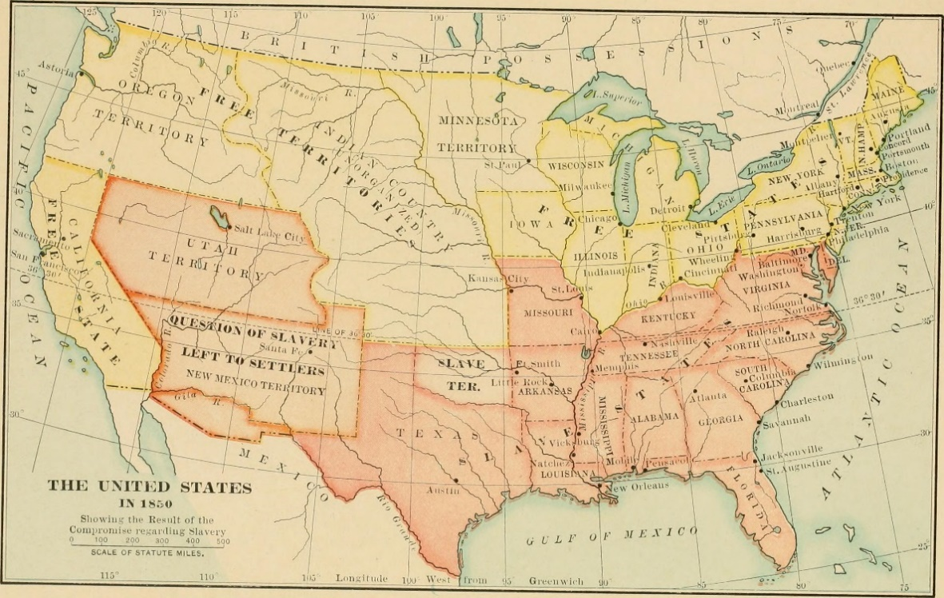

1. After reviewing this map, list the following:

**Free Territories:**

**Slave Territories:**

**Territories where slavery would be left to settlers (“popular sovereignty”):**

## **Activity D: Political Cartoon, “**[**The Clay Compromise: A Settler**](https://digital.librarycompany.org/islandora/object/Islandora%3A65074)**”**

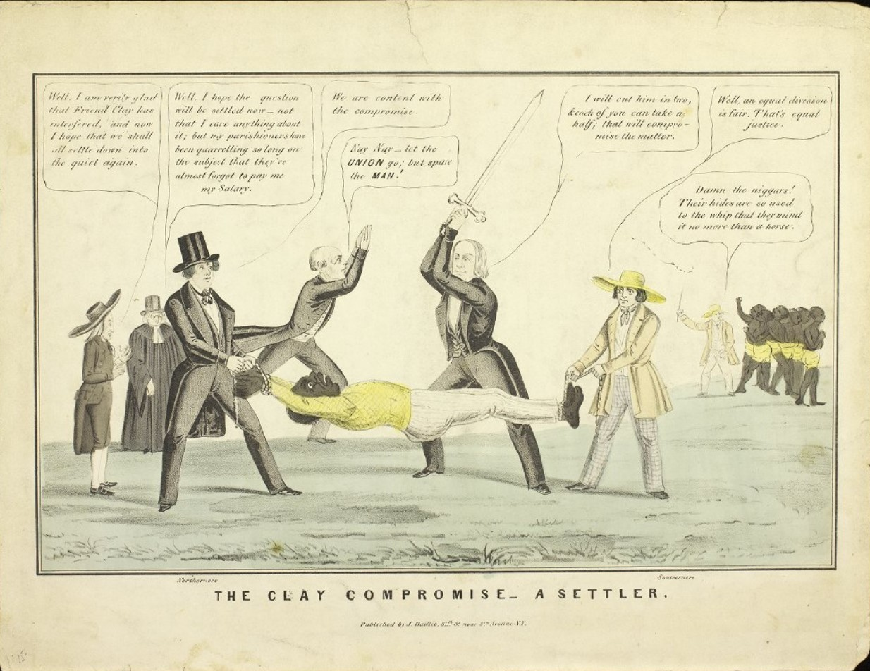

1. Write down what you notice first with this cartoon.
2. List at least five people, objects, or activities you see in this cartoon.
3. Look at the man being held down in the middle of the cartoon. What do you think he symbolizes?
4. Several people in this cartoon are expressing their opinions in dialogue boxes. Read the dialogue (click on the hyperlink to zoom in further) and describe what you think their viewpoint is on the Compromise of 1850:

**Four men on the left described as “Northerners”:**

**Senator Henry Clay (holding the sword):**

**Two men on the right described as “Southerners”:**

1. What do you think is the primary message of this cartoon?

## **Activity D: Political Cartoon, “**[**Congressional Scales: A True Balance**](https://historymaking.org/textbook/files/original/773ff38a3fe08dfba7b869dff56824e1.jpg)**”**

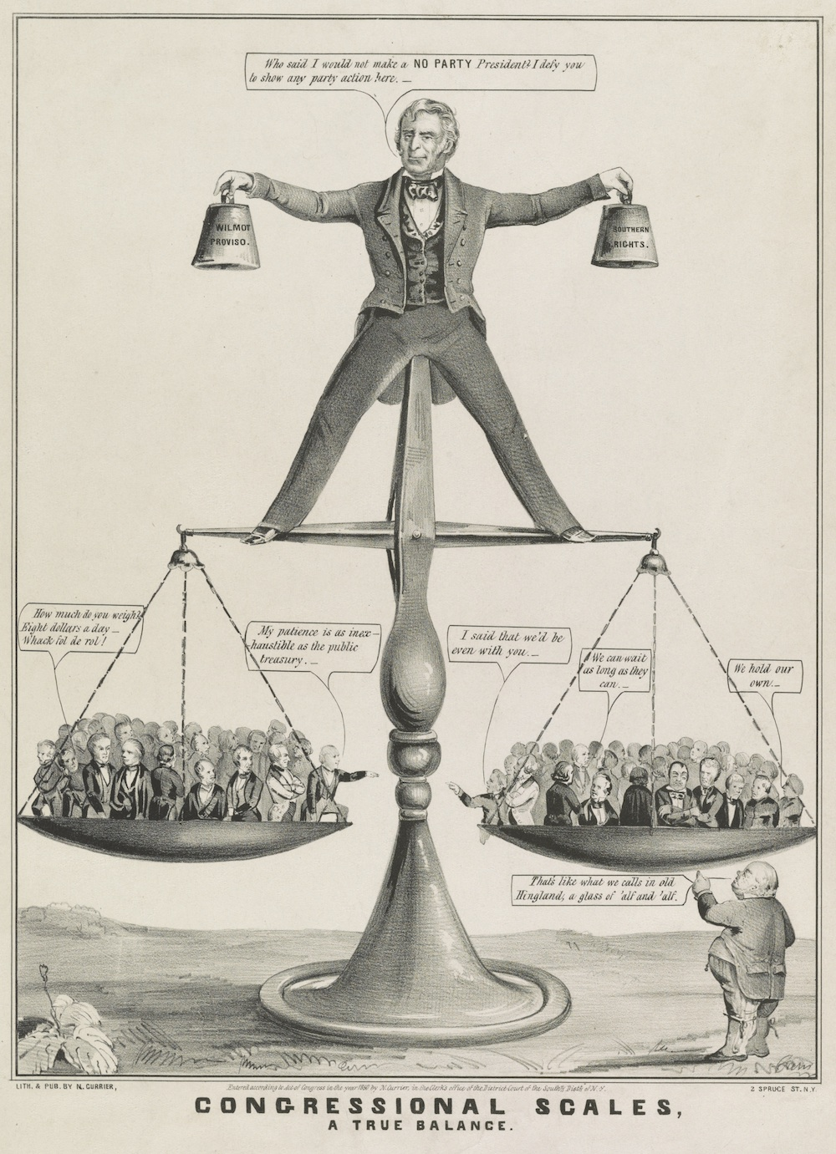

*(The “Wilmot Proviso” was a proposal made by Congressman David Wilmot during the Mexican-American War. He argued that any lands acquired from Mexico should be closed to slavery, a position strongly favored by opponents of slavery. The proposal was rejected by Congress after the war).*

1. List four objects, people, or activities you notice in this cartoon.
2. What do think the men in the scales are trying to argue to each other?
3. Look at the man standing on the scale. Who do you think he represents? What does he mean when he says he wants to be a “NO PARTY President?”
4. What do you think is the primary message of this political cartoon?

## **Activity D: Political Cartoon, “**[**Effects of the Fugitive Slave Law**](https://americanantiquarian.org/earlyamericannewsmedia/files/original/e60730ab4e962005f46ef3e4f793077e.jpg)**”**

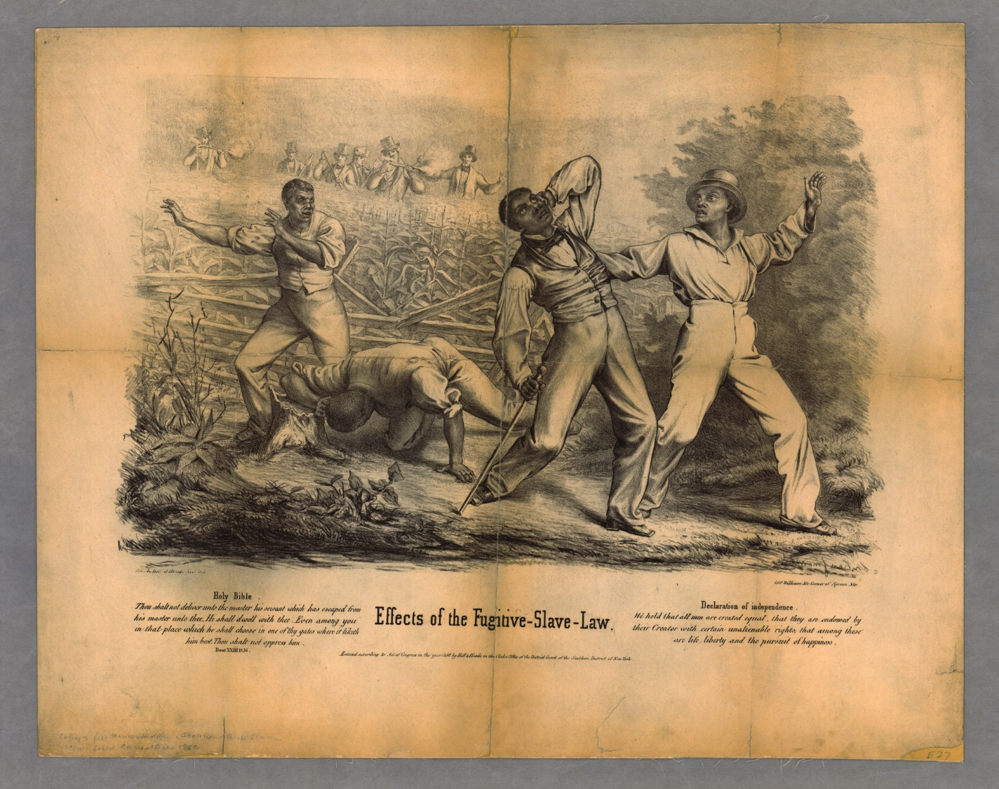

1. What is the first thing you notice about this cartoon?
2. In at least three sentences, describe the action going on in this cartoon between the four men in foreground and the six men in the background.
3. Look at the text at the bottom of the cartoon (click on the hyperlink for a closer view). Why do you think this text was included?
4. In your opinion, what is the perspective of the artist with regards to the Fugitive Slave Law? Describe your argument in at least three sentences.

## **Activity E: Senator Daniel Webster, “Seventh of March Speech”**

*Daniel Webster was an antislavery Senator from Massachusetts. Known for his powerful speeches, Webster explains in this speech why he supported the Compromise of 1850. Senator Webster lost his seat in Congress after making this speech.*

“I wish to speak to-day, not as a Massachusetts man, nor as a Northern man, but as an American, and a member of the Senate of the United States . . .  I speak to-day for the preservation of the Union. "Hear me for my cause." I speak to-day, out of a [concerned] and anxious heart for the restoration to the country of that quiet and harmony which make the blessings of this Union so rich, and so dear to us all.

Upon the general nature and influence of slavery there exists a wide difference of opinion between the northern portion of this country and the southern. It is said on the one side, that, although not the subject of any injunction [order] or direct prohibition in the New Testament, slavery is a wrong . . . The South, upon the other side, having been accustomed to this relation between two races all their lives, from their birth, having been taught, in general, to treat the subjects of this bondage with care and kindness, and I believe, in general, feeling great kindness for them, have not taken the view of the subject which I have mentioned. There are thousands of religious men, with consciences as tender as any of their brethren at the North, who do not see the unlawfulness of slavery.

[The constitution] says that those [enslaved] persons escaping to other States "shall be delivered up," and I confess I have always been of the opinion that it was an injunction upon the States themselves. When it is said that a person escaping into another State, and coming therefore within the jurisdiction of that State, shall be delivered up, it seems to me the import of the clause is, that the State itself, in obedience to the Constitution, shall cause him to be delivered up. That is my judgment. I have always entertained that opinion, and I entertain it now . . . Then, Sir, there are the Abolition societies, of which I am unwilling to speak, but in regard to which I have very clear notions and opinions. I do not think them useful. I think their operations for the last twenty years have produced nothing good or valuable.

I should much prefer to have heard from every member on this floor declarations of opinion that this Union could never be dissolved, than the declaration of opinion by any body, that, in any case, under the pressure of any circumstances, such a dissolution was possible. I hear with distress and anguish the word "secession," especially when it falls from the lips of those who are patriotic, and known to the country, and known all over the world, for their political services . . . our ancestors, our fathers and our grandfathers, those of them that are yet living amongst us with prolonged lives, would rebuke and reproach us; and our children and our grandchildren would cry out shame upon us, if we of this generation should dishonor these [symbols] of the power of the government and the harmony of that Union which is every day felt among us with so much joy and gratitude.

Let us come out into the light of day; let us enjoy the fresh air of Liberty and Union . . . let us devote ourselves to those great objects that are fit for our consideration and action.”

1. Daniel Webster tried to explain why Northerners and Southerners had different opinions about slavery. It at least three sentences, summarize Webster’s interpretation of this disagreement.
2. Webster also offers an interpretation of the U.S. Constitution in this speech. What did he believe the Constitution had to say about fugitive slaves? Which section of the country did he side with?
3. What do you think were the “abolition societies” that Webster refers to, and why did he think they were useless?
4. What, in your opinion, do you think was Webster’s biggest fear about the future of the United States?

## **Activity E: Senator John C. Calhoun Speech Against the Compromise of 1850**

*John C. Calhoun was a proslavery Senator from South Carolina. He believed any restriction against slavery’s expansion into new Western states was unconstitutional. In this March 4, 1850 speech, Calhoun explains why he opposed the Compromise of 1850*.

I have believed from the first that the agitation of the subject of slavery would, if not prevented by some timely and effective measure, end in disunion. Entertaining this opinion, I have, on all proper occasions, endeavored to call the attention of each of the two great parties which divide the country to adopt some measure to prevent so great a disaster, but without success . . .

The census is to be taken this year, which must add greatly to the decided preponderance of the North in the House of Representatives and in the electoral college . . . Two Territories, Oregon and Minnesota, are already in progress, and strenuous efforts are making to bring in three additional States from the territory recently conquered from Mexico. If successful, it will add three other States in a short time to the northern section. On the contrary, there is not a single territory in progress in the southern section. This great increase of Senators . . . will effectively destroy the equilibrium [equality] which existed when the Government [was created] . . .

A single section, governed by the will of the numerical majority, has now, in fact, the control of the Government and the entire powers of the system. What was once a constitutional Federal Republic is now converted, in reality, into one as absolute as that of the Autocrat of Russia, and as despotic in its tendency as any absolute Government that ever existed . . . as the North has the absolute control over the Government, it is manifest that on all questions between it and the South, . . . the interests of the latter will be sacrificed to the former. The South possesses no means by which it can resist through the action of the Government.

 I refer to the relation between the two races in the southern section, which constitutes a vital portion of her social organization. Every portion of the North entertains views and feelings more or less hostile to it. Those most oppressed and hostile regard it as a sin, and consider themselves under the most sacred obligation to use every effort to destroy it . . . Those less opposed and hostile, regard it as a crime . . . those who are least opposed and hostile, regard it as a blot and a stain on the character of what they call the nation . . . On the contrary, the southern section regards the relation as one which cannot be destroyed without subjecting the two races to the greatest calamity, and the section to poverty, desolation, and wretchedness; and accordingly, they feel bound by every consideration of interest and safety, to defend it . . . The increasing power of this Government . . . [is] enough to put the most fanatical portion of the North in action for the purpose of destroying the existing relation between the two races in the slave. . .

How can the Union be saved? To this I answer, there is but one way by which it can be, and that is, by adopting such measures as will satisfy the States belonging to the southern section that they can remain in the Union consistently with their honor and their safety . . . to do justice by conceding to the South an equal right in the acquired territory, and to do her duty by causing the stipulations relative to fugitive slaves to be faithfully fulfilled [and] to cease the agitation of the slave question.

1. The census tracks the total population of the United States and is taken every ten years. In at least three sentences, describe what concerned Calhoun about the 1850 census. What was the “equilibrium” he refers to in this speech?
2. Why did Calhoun believe the United States was no longer a republic but more like an autocracy (a country run by one person who holds all the power)?
3. In at least three sentences, summarize Calhoun’s views towards slavery. What did Calhoun fear if slavery came to an end?
4. What were Calhoun’s proposed solutions for ending disagreements over slavery? In your opinion, were his ideas fair to the North as well as the South?

## **Activity E: Frederick Douglass, “The Fugitive Slave Law,” August 1852**

*Frederick Douglass was an African American man who had been enslaved in Maryland, but successfully ran away to freedom in 1838 at the age of 20. He lived in both Massachusetts and New York after running away, but the Fugitive Slave Act of 1850 led Douglass to fear that he could someday be captured and sold back into slavery. In this speech, Douglass addressed the “Free-Soil” Party convention and explained his opposition to the Fugitive Slave Act.*

“I am, of course, for circumscribing and damaging slavery in every way I can. But my motto is extermination [of slavery]—not only in New Mexico, but in New Orleans—not only in California but in South Carolina. Nowhere has God ordained that this beautiful land shall be cursed with bondage by enslaving me. Slavery has no rightful existence anywhere. The slaveholders not only forfeit their right to liberty, but to life itself. The land is God’s, and it ought to be covered with righteousness, and not slavery . . .

The only way to make the Fugitive Slave Law a dead letter is to make half a dozen or more dead kidnappers [slave catchers trying catch enslaved runaways in the North]. A half dozen more kidnappers carried down South would cool the [enthusiasm] of Southern gentleman, and keep their [aggressiveness] in check. That is perfectly right as long as the colored man has no protection. The colored men’s rights are less than those of a donkey. No man can take away a donkey without submitting the matter to twelve men [on a jury] in any part of this country. A black man may be carried away without reference to a jury. It is only necessary to claim him, and that some villain should swear to his identity. There is more protection [in this country] for a horse, for a donkey, or anything, rather than a colored man—who is, therefore, justified in the eye of God, in maintaining his right with his [firearm].

The man who takes the office of a bloodhound ought to be treated as a bloodhound; and I believe that the lines of eternal justice are sometimes so obliterated by a course of long continued oppression that it is necessary to revive them by deepening their traces with the blood of a tyrant . . . [this law] makes it criminal for you, sir, to carry out the principles of Christianity. It forbids you the right to do right—forbids you to show mercy—forbids you to follow the example of the good Samaritan.

It has been said that our fathers entered into a covenant [agreement] for this slavecatching. Who were your daddies? I take it they were men, and so are you . . . If you look over the list of your rights, you do not find among them any right to make a slave of your brother.

It is a fundamental truth that every man is the rightful owner of his own body. If you have no right to the possession of another man’s body your fathers had no such right. But suppose that they have written in a constitution that they have a right [to own slaves], you and I have no right to conform to it. Suppose you and I had made a deed to give away two or three acres of blue sky; would the sky fall—and would anyone be to plough it? You will say that this is an absurdity, and so it is. The binding quality of law is its [fairness]. I am safe, therefore that you will take the ground that this slavery is a system, not only of wrong, but is of a lawless character, and cannot be Christianized nor legalized.”

1. After reading this speech, list three different points Douglass makes to argue that slavery was wrong.
2. What was Douglass’s plan to make the Fugitive Slave Law “a dead letter”? On what grounds did he justify his argument?
3. Why did Douglass argue that the Fugitive Slave Law was un-Christian? Explain your reasoning in at least two sentences.
4. In your opinion, is violence ever justified as a way to fight unjust laws?

## **Dialogue Program Model: “When is Compromise Necessary? The Compromise of 1850”**

Begin with brief introduction of facilitator and topic. Lay out ground rules, including the following:

* Use “I” statements. Speak only for yourself, not others.
* “Share the air.” Leave room for everyone to speak freely without interruption.
* Everyone possesses a particular social status that shapes their life experiences. You don’t have to agree with all perspectives shared during the dialogue, but seek understanding and empathy for others’ experiences.
* Be willing to examine your own biases and assumptions.

### **Phase I – Community Building: Invite participants to share information about their lives while learning from others. Pose a non-threatening “ice breaker” question to start the dialogue.**

Politics is the art of compromise. When multiple political parties must work together to pass new laws and policies, both sides often have to give up something they cherish in the interest of the public good. But is compromise always a good thing? Are there times when it’s wiser to stick to your personal values than to compromise on something you feel strongly about? With the issue of slavery in the United States, numerous compromises were made on the issue of slavery in the interest of promoting sectional harmony. The Compromise of 1850 was an example of this legislation. It banned slavery in California and ended the slave trade in Washington, D.C., but it also led to a stronger Fugitive Slave Law and left open the possibility of slavery’s expansion to Utah and New Mexico territories.

* **What do you think of when you hear the word “compromise”?**
* **Think of a time when you realized you weren’t going to get your way on something. How did you feel in that moment?**

### **Phase II – Sharing Our Own Experiences: Provide an opportunity for participants to recognize how their experiences are alike and different and why.**

Senator Henry Clay of Kentucky felt very strongly about the importance of compromise. When Missouri first applied for statehood in 1819, he helped pass legislation allowing Missouri to come into the Union as a slave state while Maine came in as a free state. Clay believed that if there was an equal number of slave and free states in the Union, both sides would respect each other and be equally represented in Congress. He also supported the Compromise of 1850 for the same reason, believing that an end to debates about slavery would ensure the stability of the Union.

* **Share a time when you had to compromise on your values.**
* **When have you had to give up something important to you?**

### **Phase III – Going Beyond Ourselves: Explore the topic beyond personal experiences in an effort to learn with and from one another.**

Members of Congress who supported the Compromise of 1850 soon realized that some voters in both the North and South were outraged at this legislation. Senator Daniel Webster of Massachusetts was soon removed from office after speaking in support of the Compromise. For Northerners, the South’s “peculiar institution” had been given special protection by Congress for too long. For Southerners, they resented attacks against slavery and argued that it was their constitutional right to own property in humans. Despite the best efforts of Clay, Webster, and other Congressmen to work out a fair compromise, the American Civil War broke out eleven years later in 1861.

**Pre-visit Articles and Anthony Burns video:** The ranger will lead a discussion using the questions listed in the pre-visit articles and video about Anthony Burns.

**Political Cartoons:** Students will discuss three different political cartoons that they studied prior to the virtual meeting.

**Speeches:** Students will discuss three different speeches and letters that they studied prior to the virtual meeting.

### **Phase IV – Synthesizing the Experience: Reflect on the dialogue and establish meaning from the ideas, perspectives, and insights generated. Discuss steps for moving forward.**

* **In your opinion, is compromise a good thing?**
* **Is violence ever justified as a way to fight unjust laws?**
* **What is one idea or insight that you will take away from today’s experience?**
* **How has this conversation challenged your assumptions?**